SQL Server

Test of Sql Server

Jyot Hathi

2021

Index

**A.** **Given Reference Table Creation and Data Insertion** 3

**1.** **Employee Table:** 3

**2.** **Department Table (To Normalize Employee Table):** 4

**3.** **Incentive Table:** 4

**B.** **Execution of Give Queries:** 5

**1.** **Get First_Name from employee table using alias name “Employee Name”** 5

**2.** **Get position of 'o' in name 'John' from employee table** 5

**3.** **Get FIRST_NAME ,Joining year,Joining Month and Joining Date from employee table** 5

**4.** **Get all employee details from the employee table order by First_Name Ascending and Salary descending.** 6

**5.** **Get employee details from employee table whose employee name are not “John” and “Roy”.** 6

**6.** **Get employee details from employee table whose first name ends with 'n'.** 6

**7.** **Get employee details from employee table whose first name ends with 'n' and name contains 4 letters.** 7

**8.** **Get employee details from employee table whose Salary less than 800000** 7

**9.** **Get employee details from employee table who joined before January 1st 2013** 7

**10.** **Get difference between JOINING_DATE and INCENTIVE_DATE from employee and incentives table** 8

**11.** **Print database date.** 8

**12.** **Get department,total salary with respect to a department from employee table.** 8

**13.** **Get department,no of employees in a department,total salary with respect to a department from employee table order by total salary descending .** 9

**14.** **Select no of employees joined with respect to year and month from employee table.** 9

**15.** **Update incentive table with employee's Incentive_amount as '12000' where employee name is 'John'** 9

**16.** **Select TOP 2 salary from employee table** 10

**17.** **Select 2nd Highest salary from employee table** 10

**18.** **Write. What is the difference between UNION and UNION ALL?** 10

**19.** **Write a syntax for CREATE Employee Table.** 10

**20.** **Write a syntax for truncate all data from Emplyee Table.** 11

**21.** **Write a syntax for CREATE Procedure to display the Employee details by passing the “Employee Id” in the procedure.** 11

**22.** **Write a syntax for CREATE SQL function, which accept three number as argument and return the highest number.** 11

**23.** **Write a syntax for Update the Employee's salary whose department is “Insurance”.** 12

**24. State the difference between varchar and nvarchar.** 12

**25. Write a query that insert the data into Employee table, data as mentioned. {First name : 'Critiano' , Last name : 'Ronaldo' , Salary : '30000' , Joining Date : '01-FEB-13 12.00.00 AM' , Department : 'Banking' }** 12

# **Given Reference Table Creation and Data Insertion**

## **Employee Table:**

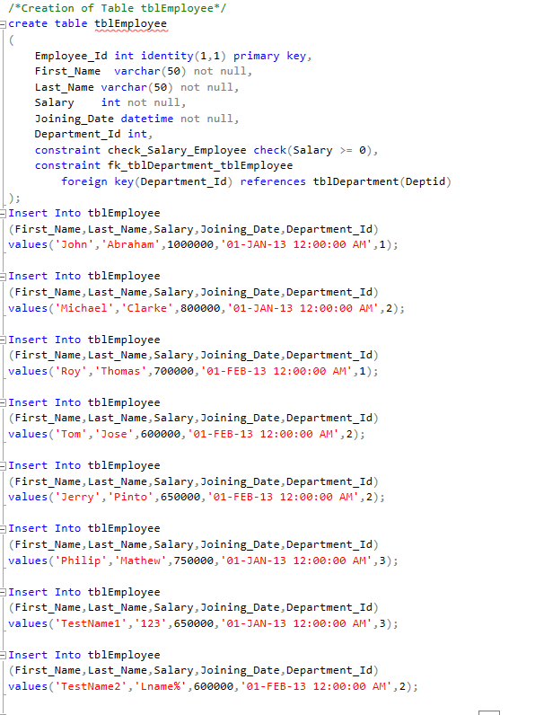

## **Department Table (To Normalize Employee Table):**

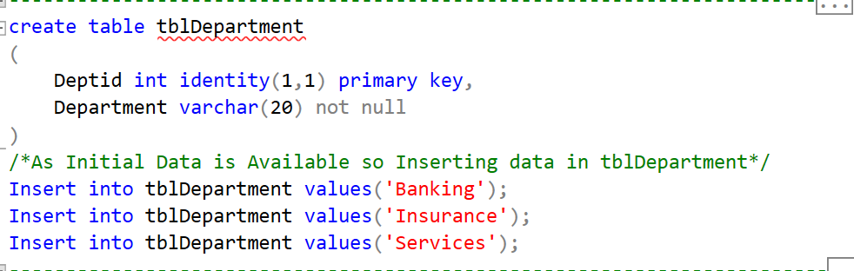

## **Incentive Table:**

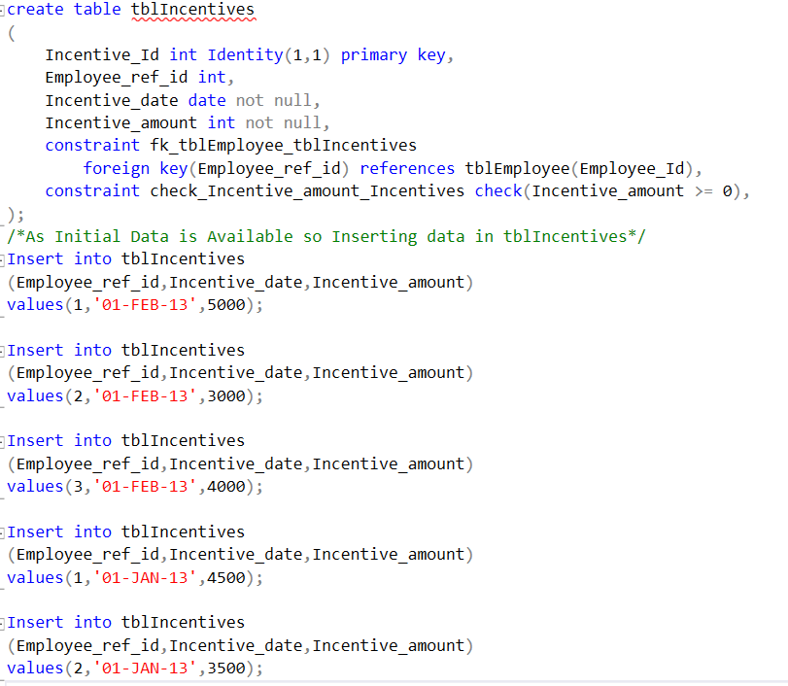

# **Execution of Give Queries:**

## **Get First_Name from employee table using alias name “Employee Name”**



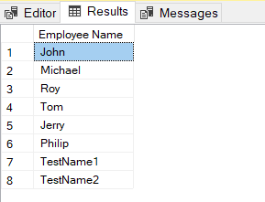

## **Get position of 'o' in name 'John' from employee table**



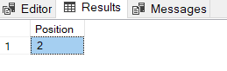

## **Get FIRST_NAME ,Joining year,Joining Month and Joining Date from employee table**

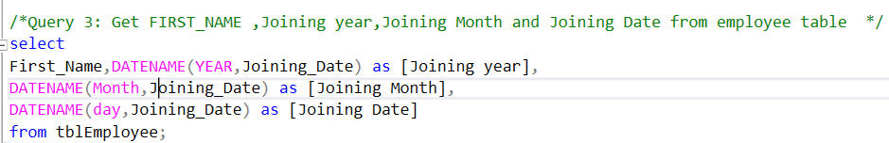

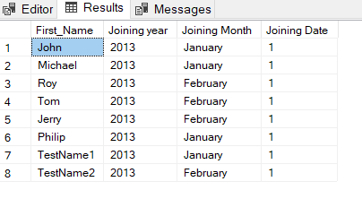

## **Get all employee details from the employee table order by First_Name Ascending and Salary descending.**

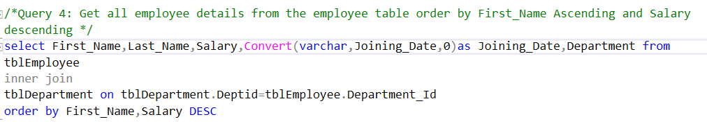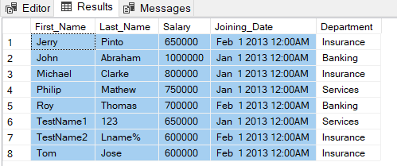

## **Get employee details from employee table whose employee name are not “John” and “Roy”.**

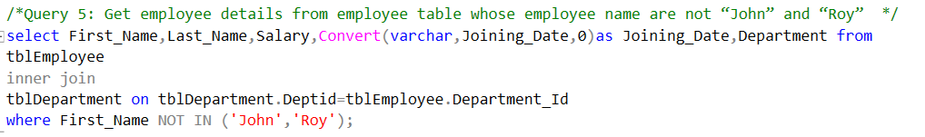

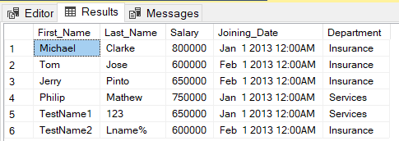

## **Get employee details from employee table whose first name ends with 'n'.**

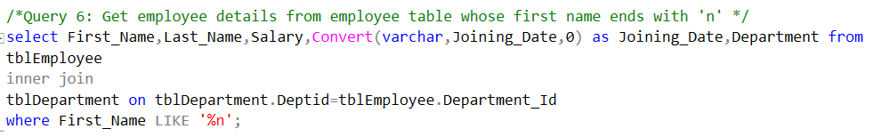

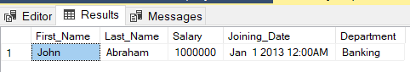

## **Get employee details from employee table whose first name ends with 'n' and name contains 4 letters.**

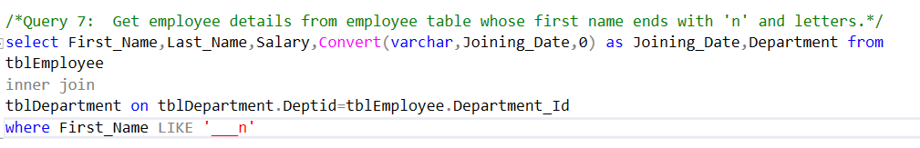

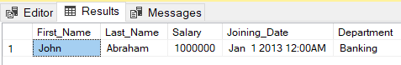

## **Get employee details from employee table whose Salary less than 800000**

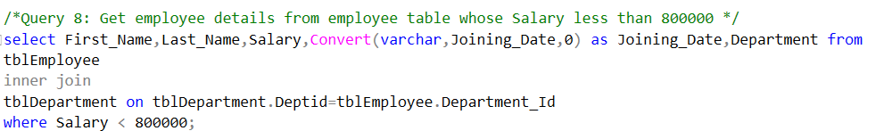

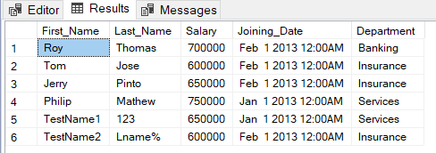

## **Get employee details from employee table who joined before January 1st 2013**

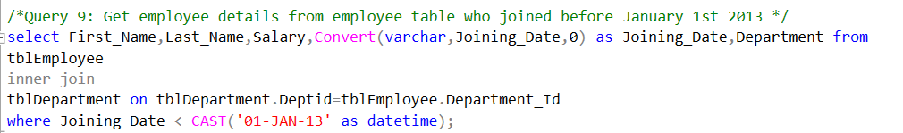

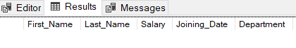

## **Get difference between JOINING_DATE and INCENTIVE_DATE from employee and incentives table**

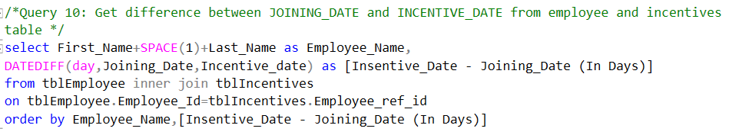

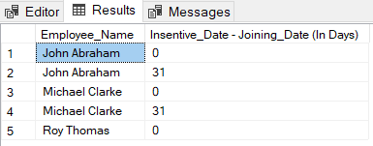

## **Print database date.**

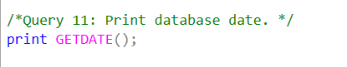

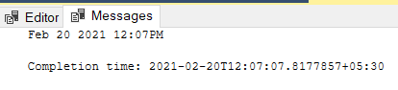

## **Get department,total salary with respect to a department from employee table.**

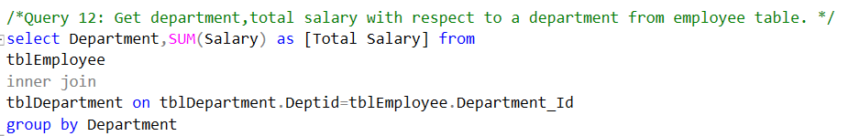

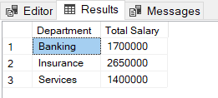

## **Get department,no of employees in a department,total salary with respect to a department from employee table order by total salary descending .**

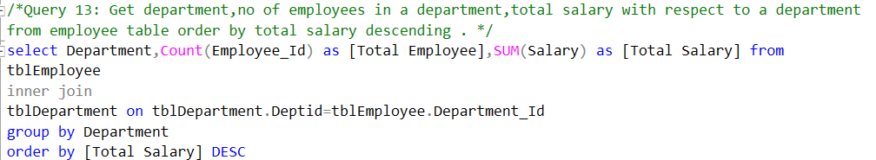

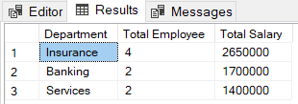

## **Select no of employees joined with respect to year and month from employee table.**

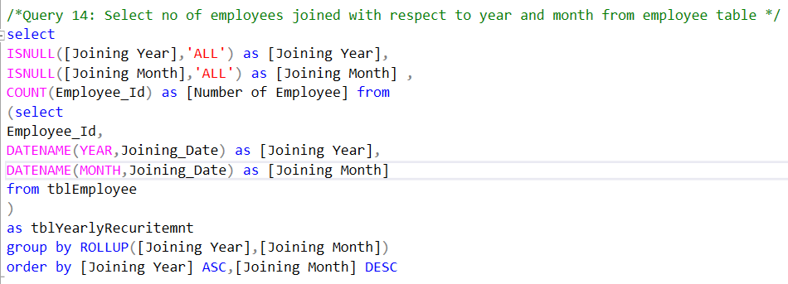

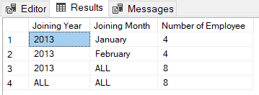

## **Update incentive table with employee's Incentive_amount as '12000' where employee name is 'John'**

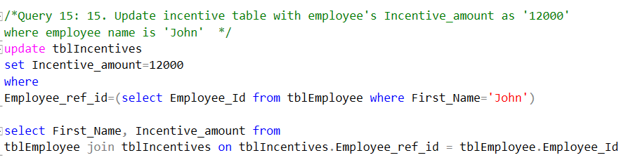

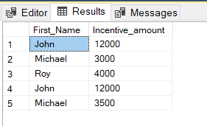

## **Select TOP 2 salary from employee table**

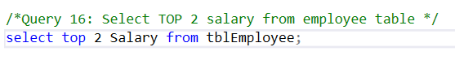

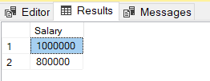

## **Select 2nd Highest salary from employee table**

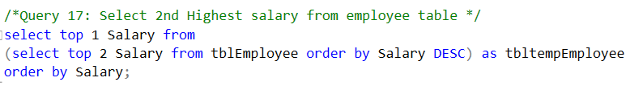

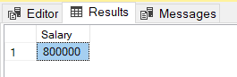

## **Write. What is the difference between UNION and UNION ALL?**

Ans:

1. Union All Not Remove the Duplication of Records
2. Whereas UNION First Remove Duplication and Then Display Data.

## **Write a syntax for CREATE Employee Table.**

Ans:

Create table tblEmployee

(

EmployeeId int Identity(1,1) primary key,

First_Name varchar(50) not null,

Last Name varchar(50) not null,

Salary int not null,

Joining_Date datetime not null,

Department varchar(50),

Constraint ck_Salary_tblEmployee CHECK(Salary >=0)

);

**Note**: Here We Can Normalize the table By Create Department Table and then have to set reference of that to employee table instead of Department Manually.

## **Write a syntax for truncate all data from Emplyee Table.**

Ans.

TRUNCATE table tblEmployee;

## **Write a syntax for CREATE Procedure to display the Employee details by passing the “Employee Id” in the procedure.**

Ans.

Create proc sp_tblEmployee

@EmployeeId int =0

As

Begin

Select * from tblEmployee where [Employee Id] = @ EmployeeId;

End

## **Write a syntax for CREATE SQL function, which accept three number as argument and return the highest number.**

Ans.

Create function fc_HighestNumber(@number1 int, @number2 int ,@number3 int)

Returns int

As

Declare @highest int;

Begin

If @number1 > @number2 AND @number1 > @number3

Set @ highest= @number1;

Else if @number2 > @number3

Set @ highest= @number2;

Else

Set @ highest= @number3;

Return @ highest;

End

## **Write a syntax for Update the Employee's salary whose department is “Insurance”.**

Ans:

1. If Employee Is Not Normalized by creating Separate Department table

Update tblEmployee

Set Salary=<new Salary>

Where Department = ‘Insurance’

1. If Employee Is Normalized by creating Separate Department table

Update tblEmployee

Set Salary=<new Salary>

Where DepartmentId = (select DeptId from tblDepartment where Department = ‘Insurance’);

## **State the difference between varchar and nvarchar.**

Ans:

1. varchar store data as 8-bit representation so it requires less size to store
2. nvarchar store data as Unicode Format (16-Bit Representation) so It Take More Amount of storage in compare of varchar.

## **25. Write a query that insert the data into Employee table, data as mentioned. {First name : 'Critiano' , Last name : 'Ronaldo' , Salary : '30000' , Joining Date : '01-FEB-13 12.00.00 AM' , Department : 'Banking' }**

Ans:

1. If Employee Is Not Normalized by creating Separate Department table

Insert into tblEmployee

(First_Name,Last_Name,Salary,Joining_Date,Department)

Values('Critiano', 'Ronaldo', 30000, 01-FEB-13 12:00:00 AM, 'Banking');

1. If Employee Is Normalized by creating Separate Department table

Insert into tblEmployee

(First_Name,Last_Name,Salary,Joining_Date,Department_Id)

Values('Critiano', 'Ronaldo', 30000, 01-FEB-13 12:00:00 AM,1);

**Note**: Here 1 is Department id from tblDepartment whose Department Value is Banking